Q.1 Write a short paragraph in your own words defining what a 'program' is and give one real-life example from any app you use daily.
Program : Program is a set of instructions. That tells a computer or mobile device what tasks to perform.
For example, in Paytm, a program processes a payment when you scan a QR code: it checks the payment details, transfers the money from your account to the receiver, and shows a confirmation message.

Q.2 List three popular programming languages you have heard of, and for each, mention whether it is usually compiled, interpreted, or can be both .
Java | Interpreted + Compiled
Python | Interpreted
Java script | Interpreted + Compiled
Three programming languages:

Q.3 Draw a flowchart for the process of booking a movie ticket on BookMyShow , starting from opening the app to receiving the booking confirmation.
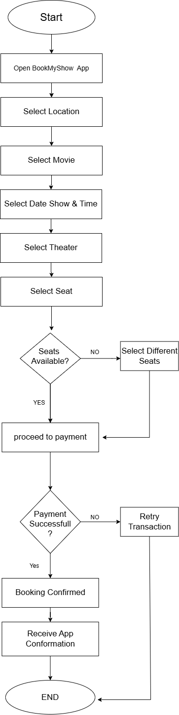
Q.4 Write down the steps (as an algorithm, using simple numbered instructions) for ordering food on Swiggy — from opening the app to completing payment.
Steps for ordering food on Swiggy :
1.Open the App
2.Select the location
3. Search for the restaurant and select one from the list
4.Choose the food items you want to order
5.Add items into cart
6.Open the cart and check amount
7. Confirm delivery address
8.Select payment method
9.Click proceed to pay/place order
10.Complete the payment
11. Receive the order confirmation
12.Track order until deliver.

